Biometrics Systems Security
01 Metrics
Wilson Kinda: 222075

Exercise 1
Compute d' for the content of /content/test.csv.
For /content/test.csv:
- Impostor observations: 50
- Genuine observations: 50
- Impostor mean: 0.345342
- Genuine mean: 0.731026
- Impostor variance: 0.025400617636
- Genuine variance: 0.039974415124
Using the supplied formula: d_prime = 2.13324462836214. So, approximately: d' = 2.13
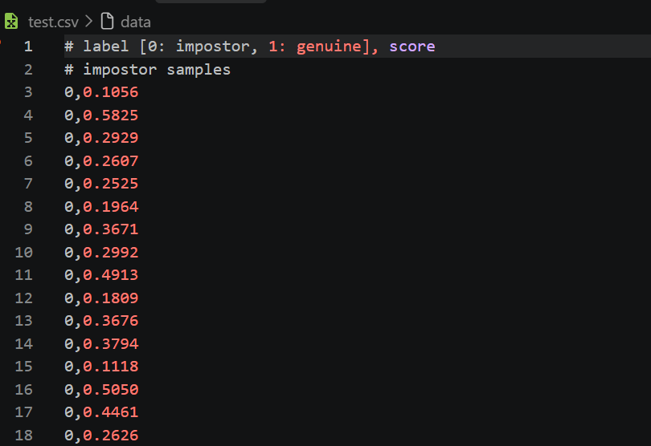
Exercise 2: Threshold meaning
The threshold is the minimum similarity score required to accept a match:
- score >= threshold: accept the match
- score < threshold: reject the match
- Increasing the threshold generally decreases FMR and increases FNMR.
Exercise 3: FMR and FNMR at EER
fnmr, fmr, eer_threshold = compute_sim_fmr_fnmr_eer(output)

print("FNMR:", fnmr)
print("FMR:", fmr)
print("EER threshold:", eer_threshold)
Result:
FNMR: 0.16
FMR: 0.16
EER threshold: 0.5374

Exercise 4: FMR versus TMR AUC
auc, fmrs, tmrs = compute_sim_fmr_tmr_auc(output)
print("AUC:", auc)
Result:
AUC: 0.9376
Exercise 5: Histogram
plot_hist(output)
This plots impostor scores in red and genuine scores in blue. The title should show approximately: Score distribution, d'=2.13
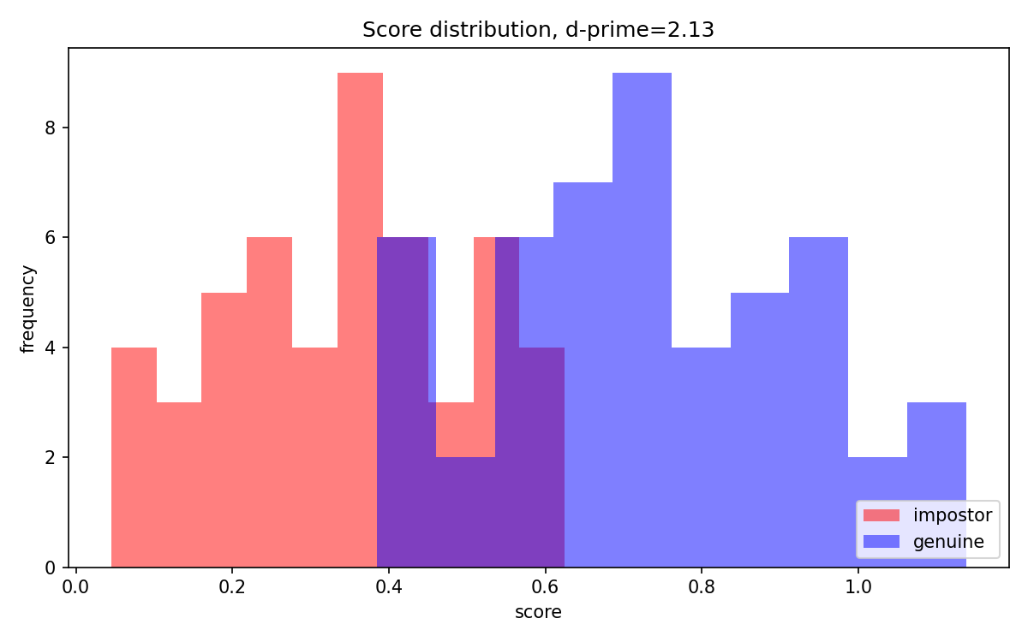
Exercise 6: ROC/AUC plot
plot_sim_fmr_tmr_auc(output)
The plot displays the FMR versus TMR curve with: AUC: 0.94

